

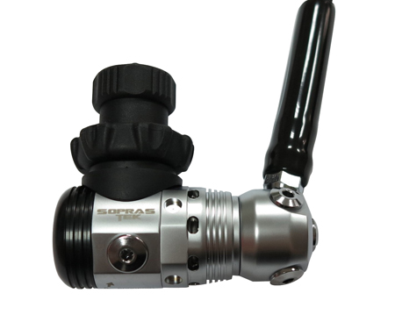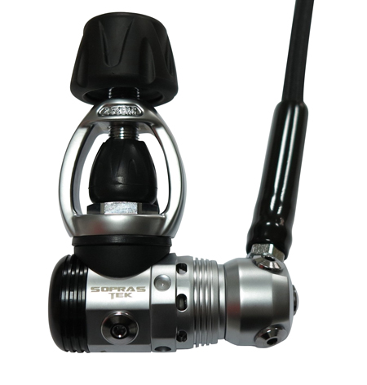

TABLE OF CONTENTS

1. Introduction MINERVA (103)

2.0 Specifications

2.1 Torque Specifications

3.0 Service Kit List

3.1 Service Tool List

4.0 Service Procedures

4.1 Tools Required for Servicing

4.2 Disassembly

4.3 Cleaning and Inspection

4.4 Preliminary Assembly

4.5 Set-up

4.6 Dry Environmental version

5.0 Helpful Hints

5.1 Troubleshooting

5.2 Parts Cleaning Recommendations

5.3 Commonly Used Cleaning Solutions

5.4 Handling Tips

Before You Begin ...........

Read these instructions completely before you begin servicing the regulator or filling whip.

These instructions are intended for people who have been AUTHORIZED by SOPRAS TEK to repair SOPRAS TEK Scuba equipment. If you are not so authorized - STOP.

1.0 INTRODUCTION

1.0.1 The procedures in this manual apply to the SOPRAS TEK MINERVA (103) 1st Stage Regulator , Refer to the exploded views as you read the service section of the manual. The Item Numbers referred to in the service section are those seen in the corresponding exploded view in section 2.0 SPECIFICATIONS of this manual.



NEVER tighten the hose fitting to the first stage with more than 40 in. lbs. (4.5 Nm) of torque. The inlet hose fitting will be weakened by over tightening. Failure to heed this warning may result in serious injury or death.

NOTE:

All SOPRAS TEK Scuba Regulators have service kits available which contain the parts which must be changed at every annual service no matter what their condition. The standard annual service kit part numbers are shown in the parts list. All other parts not contained in these kits must be inspected by the technician and changed if necessary. Parts will be handled under warranty, only if they have failed due to problems with material or workmanship.



SOPRAS TEK Scuba Regulators are manufactured using materials suitable for use with oxygen enriched gases (i.e. Nitrox , etc.) providing the oxygen content does not exceed 40%. Equipment intended for enriched air (Nitrox) use, must not be used with regular compressed breathing air or other gases. Regulators intended for enriched air use, can be serviced only by technicians trained by one of the major oxygen enriched air training agencies. Failure to heed this warning may result in serious injury or death.

1.0.2 This manual gives breakdowns of regulator parts, equipment specifications, servicing instructions, troubleshooting recommendations, and guidelines for proper care of SOPRAS TEK regulators. This manual is intended for use only by persons specially trained and authorized to service SOPRAS TEK Scuba equipment.

1.0.3 Anyone attempting to service or repair SOPRAS TEK Scuba regulators must have a thorough understanding of the principles of operation of scuba regulators and valves, as well as the appropriate mechanical ability. The technician must be properly trained in the safe use of compressed air and the various tools and cleaning solutions involved in the procedures outlined in this manual.

1.0.4 The best source for current part numbers for any of the parts listed in this manual is your current parts and price list from SOPRAS TEK.

1.0.5 If you have any questions, or need more information, contact your SOPRAS TEK Sales Representative or SOPRAS TEK Customer Service. You can e-mail you technical questions to SOPRAS TEK’s mail box.

2.0 SPECIFICATIONS





A.

AIR FLOW ............................. 33 cu. ft. (935 liters/min). @ 1 atmosphere

INHALATION RESISTANCE .. 0.9” -2.0” (2.3 - 5.08 cm) w.c. @ 1 atmosphere

EXHALATION RESISTANCE .. 0.6” (1.52 cm) w.c. max. @ 1 atm.

RECOMMENDED LUBRICANT LTI Christo-Lube 111®

B.

TYPE ........................... balanced Piston Regulator - swivel

WEIGHT ................................... 2.1 lb.(.95 kg)

INTERSTAGE PRESSURE ...... 135-145 psi (9.4-10 bar)  
 @ 3000 psi inlet (207 bar)

# LOW PRESSURE PORTS .... 4 (3/8”-24 UNF)

# HIGH PRESSURE PORTS ... 1 (7/16”-20 UNF)

MATERIALS ............................. Body -------- CDA-360 Brass  
O-rings ----- Buna-N   
Seat --------- TEFLON

* 1. Torque Specifications:

Description Item # Torque  
  
CAP 17 120-140 in/lbs (13.56-15.82 N.M)  
DIN HOUSING 28 16-18 ft/lb (21.70-24.41 N.M)   
YOKE RETAINER 3 23-25 ft/lb (31.19-33.90 N.M)  
DIN RETAINER 31 120-130 In/lb (13.56-14.69 N.M)  
SEAT CAP SCREW 27 120-140 in/lbs (13.56-15.82 N.M)  
SWIVEL RETAINER 15 120-140 in/lbs (13.56-15.82 N.M)  
PORT PLUGS 21,23 35-40 In/lbs (3.96-4.52 N.M)   
Hose inlet end 2-3 ft/lb (3-4 Nm)  
Hose outlet end 2-3 ft/lb (3-4 Nm)

1. SERVICE KIT LIST



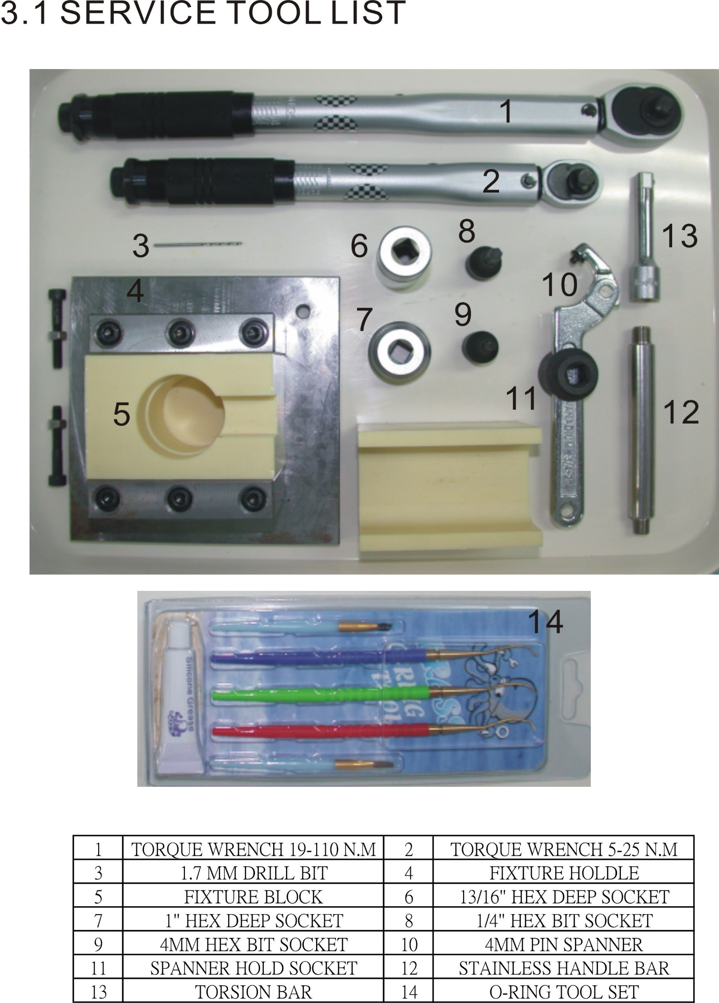

4.0 SERVICE PROCEDURES FOR THE SOPRAS TEK MINERVA (103)

4.0.1   
Before you begin disassembly of the regulator, test the first and second stages for output pressures and leakage. Pre-testing in this way will help the technician to pinpoint any specific problems requiring repair.

4.0.2   
The work area must be clean and well lighted, with clean compressed air available to blow sand and dirt from parts.

4.1 TOOLS AND PARTS LIST REQUIRED FOR SOPRAS TEK SERVICING

- Fixture block (supply from SOPRAS TEK) OR Soft-jawed bench vise (bench vise with rubber, plastic, aluminum or plastic jaw inserts)

- PIN SPANNER AND HOLD SOCKET FOR END CAP(17)

- 1" HEX SOCKET FOR YOKE RETAINER(3)

- 4MM HEX BIT SOCKET FOR PORT PLUG(18,20)

- 1.70MM DRILL BIT FOR HP SEAT(26)

- 13/16" HEX DEEP SOCKET FOR DIN HOUSING(21)

- 1/4" HEX BIT SOCKET FOR DIN RETAINER(31),SEAT CAP SCREW(27),  
SWIVEL RETAINER(15)

- 5~25N.M - 3/8" TORQUE WRENCH ADJUSTABLE

- 19~110N.M - 3/8" TORQUE WRENCH ADJUSTABLE

- STAINLESS HANDLE BAR

- 1st STAGE ANNUAL SERVICE KIT

- CLEAN SHOP RAGS

- LTI Christo-Lube 129®, or Dow-Corning 111® Silicone Grease

- Intermediate Pressure Testing Gauge

4.2 DISASSEMBLY OF THE SOPRAS TEK FIRST STAGE FOR OVERHAUL

To view all of the parts used in the SOPRAS TEK first stage, look at the inside front cover of this manual. The bracketed numbers in the text refer to the corresponding circled item numbers on the exploded view drawing.

4.2.1   
Use the 6” and 8” adjustable wrenches to loosen the hose nut from the PORT of 1st stage. Remove the hose assembly from the second stage. Inspect the hose assembly for any cuts or cracks, especially on the hose at the metal ferrules. Blow the interior bores of the hoses.   
  
Replace the hose assembly if any cuts or cracks are found. Remove and discard the O-rings from each end of the hose. Clean, rinse, and blow-dry the interior bores of the hoses. Replace the hoses if necessary.

Note:

Hose Protectors are easier to slide back from the 1st stage end of the hose if they are twisted and pulled when the hose is still installed in the 1st stage. If a hose protector is particularly difficult to pull back, try removing the hose and soaking the hose protector end in hot water to soften it up. Temporarily reinstall the hose and try pulling and twisting the hose protector again.

* + 1. Put the body into the fixture block or clamp carefully in a soft-jawed bench vise. Use 1" HEX SOCKET to loosen and remove the yoke retainer (3), the dust cap (6) and saddle (7). Remove the yoke knob assembly (1) from the yoke (2).

Note:

If the regulator has a DIN wheel, use a 1/4" HEX BIT SOCKET to remove the DIN retainer (31) and DIN wheel (29), use a 13/16" HEX DEEP SOCKET to remove Din housing (28).

4.2.3   
Remove the inlet filter (4), the filter O-ring (5), the DIN inlet O-ring (32) and Din retainer o-ring (30) if the regulator is DIN equipped. Discard all o-ring.

4.2.4  
Use a 4MM HEX BIT SOCKET to remove all port plugs (21, 23) from the body. Discard the port plug O-rings. (20, 22)

4.2.5  
STAINLESS HANDLE BAR screw in hp port. Put the body into the fixture block or on the table. Use the PIN SPANNER to remove the Cap (17) from the Body (8). Remove any Spacer(s) (10, 12), the Spring (11) and the Piston (13) from the Cap. Remove and discard the O-rings (14) from the piston. Remove and discard the O-rings (9) from the body. Whenever possible, try to remove the O-rings by pinching them with the fingers and rolling them out of the groove.



! WARNING !

If a sharp pick is used to remove the O-rings, it should be made from soft brass, not steel. ANY scratches left in the groove when removing O-rings will cause leaks (bubbling out of the Cap ambient pressure ports) and the piston will have to be replaced to stop these leaks.

4.2.6   
Put the body into the fixture block again with the hp seat cap (27) facing up. Use a 1/4" HEX BIT SOCKET to remove the seat cap (27). Remove the Seat (26) from the seat cap (27) by pushing it out with a 1.70MM DRILL BIT. Place one end of the drill bit on a flat hard surface. Lower the large end of the seat cap over the drill bit until the flat end of the drill bit rests against the back side of the Seat. Push the seat cap firmly down straight on the drill bit, until the seat is pushed out of the seat cap. Discard the old Seat. Remove the o-ring (25) from the body (8). Remove the o-ring (33) and style cap (24).

4.2.7   
STAINLESS HANDLE BAR screw in lp port swivel. Use a 5/16" HEX BIT SOCKET to remove the swivel retainer (15) and swivel washer (16) . Remove and discard the o-ring (18) from the cap (17).

4.3 Cleaning and Inspection of the 1st Stage

4.3.1   
Clean all metal parts of the first stage in an ultrasonic cleaner or cleaning solution. See Section 5.3 for recommendations on cleaning solutions. Remove the O-rings before cleaning any metal parts since the soft O-ring material will absorb cleaning energy from the ultrasonic cleaner reducing its effectiveness. If major visible corrosion or deposits exist on parts, use a bristle brush, wooden, or plastic stick to rub the deposits off. Allowing acidic cleaning solutions to do all of the work, if deposits are severe will result in damage to internal chrome plating which will make parts even more susceptible to future corrosion.

4.3.2   
Remove the regulator parts from the cleaning solution. Rinse with clean fresh water, then blow internal passageways dry with clean, dry compressed air.

4.3.3   
Inspect all O-ring grooves for scratches or wear. If the regulator was leaking air because of scratches or wear, replace the parts. If some corrosion deposits persist, carefully wipe them away with a plastic scrubbing cloth or plastic or wooden dowel. Blow any resulting dust out of the regulator parts.

4.3.4   
Closely examine the sealing cones (orifices) in the piston (13) where the Seat (26) of the Piston seal.

4.4 PRELIMINARY ASSEMBLY OF THE FIRST STAGE

4.4.1   
To determine the identity of each O-ring in the Service Kit, remove them from the bag and use the O-ring Identification Chart on the front page of this manual. Lay each O-ring over its corresponding picture on the page and read the description. Before installing new O-rings into the regulator, lightly lubricate the O-rings with LTI Christo - Lube 111 ® (for enriched air regulators), or Dow-Corning 111® silicone grease. The most effective way to lubricate the kit O-rings is to put them in a small plastic bag with a pea sized amount of grease. Rub the O-rings and grease together in the bag until all the O-rings are coated evenly. Try not to wipe the lubrication off the O-rings when assembling them onto other parts.

4.4.2   
Place the hp Seat (26) on a clean flat surface and press the seat cap (27) stem straight over the seat until the new seat is installed into the end of the Piston.

4.4.3   
Install the pre-lubricated (see 4.4.1) O-rings (14) onto the piston, O-ring (9) onto the body (8) and o-ring (16) onto the cap (17) .   
Put the swivel washer on the place of the cap (17) and insert the swivel retainer (15) into the cap(17) and then screw to the Lp swivel with the cap assembly. Tighten the swivel retainer (15) with a 5/16” HEX BIT SOCKET, follow the Torque Specifications.

4.4.4  
Carefully guide the large end of the Piston into the Cap until it bottoms. Use a gentle rocking motion if necessary to move the Piston into the Cap, but do not cock it at too severe an angle since this may cause the Piston to gouge the sealing surface of the Cap.

4.4.5   
Support the Body (8) so that the Cap threaded end is facing up. Use the same number of Shims (12, 10) that were installed in the Spring Cavity when you took the MINERVA (103) apart. If there was one shim, it goes on the Body side of the Spring (9). If there were two Shims, install one at each end of the Spring. Install the Spring (11) on top of the Shim.

4.4.6   
Lubricate the threads on the Cap (17) with grease. Put the Cap with its Piston (13) installed over the Spring and Shim sitting in the cavity of the body and screw them together as far as you can by hand.

4.4.7   
STAINLESS HANDLE BAR screw in hp port. Put the body into the fixture block or on the table. Use PIN SPANNER AND HOLD SOCKET to snug the Cap (17) onto the body with 120-140 in/lbs (13.56-15.82 N.M) of torque

4.4.8   
Put the style cap (24) into the body (8). Install the pre-lubricated (see 4.4.1) O-rings (33) onto the style cap and o-ring (25) onto the body. Screw the seat cap assembly to the body. Tighten the hp seat cap (27) with a 1/4” HEX BIT SOCKET, follow the Torque Specifications.

4.4.9   
Install the yoke retainer (3) into the yoke (2). Install the saddle (7) and the dust cap (6) onto the yoke.

4.4.10   
Install the new inlet filter (4) and filter O-ring (5) into the yoke retainer (3).

4.4.11   
Hand tighten the yoke, yoke retainer into the body.

Note:

If the regulator has a DIN connection, Install the new inlet filter (4) and filter O-ring (5) into the DIN housing (28).

Hand tighten the DIN housing (28) into the body

4.4.12   
Place the body carefully into a fixture so that the yoke retainer or DIN housing is facing up.

4.4.13   
Tighten the yoke retainer (3) or the DIN housing (28) with a 1" HEX SOCKET or 13/16" HEX DEEP SOCKET. Tighten yoke retainer to 23-25 ft/lb (31.19-33.90 N.M). Tighten din housing to 16-18 ft/lb (21.70-24.41 N.M).

4.4.14   
Install the new O-rings (30, 32) into Din retainer(31)

4.4.15  
Install the DIN wheel (29) into din housing(21) and hand tighten the din retainer(31)into the din housing.

4.4.16   
Tighten the din retainer with 1/4" HEX BIT SOCKET. Tighten din retainer (31) to 120-130 In/lb (13.56-14.69 N.M).

4.4.17   
Install new O-rings (20,22) from the kit onto port plugs (21,23) and install the port plugs into the appropriate ports. Use the 4MM HEX BIT SOCKET to tighten port plugs to 35-40 In/lbs (3.96-4.52 N.M).

4.4.18   
Install yoke knob (1) onto the yoke.

* 1. SET-UP AND TESTING THE FIRST STAGE

Note:

The MINERVA (103) regulator has a BALANCE piston 1st stage. For safety, test the first stage regulator with at least one second stage installed. The demand valve on the second stage acts as a relief valve in case of a malfunction.

4.5.1   
Install an intermediate pressure test gauge into one of the low-pressure ports of the first stage, and a functional 2nd stage into another low pressure port. Plug any remaining open outlet ports with suitable port plugs.

Attach the regulator to a tank valve giving a source pressure of between 2700 and 3500 psig (186-240 Bar).

NOTE:  
The following test determines the regulator's lock-up pressure (the pressure put out by the first stage during a no flow condition).

4.5.2   
Turn the air tank ON by SLOWLY while listening for any unusual air leaks. If any are heard, turn the air off immediately and determine the source of the leak. If no leaks are found, watch the intermediate pressure gauge reading rise as you continue turning the air on slowly. It should stop before 150 psi (10.2 bar).

4.5.3   
If the pressure gauge continues to rise above 150 psi (10.2 bar), turn the air supply off immediately and inspect the regulator to determine the cause.

4.5.4   
Depress the 2nd stage purge cover fully, then release it several times to clear particles from the regulator, and to work the internal parts into place. To prevent uncontrolled free flows after pushing the purge cover, keep the deflator knob on the second stage in the “-“ (negative position).

4.5.5   
The pressure range for MINERVA (103) Regulators at 3000 psi inlet pressure is 130-150 psi ( 9-10.2 bar). Add Shims (12) in either side of the spring (9) to raise the intermediate pressure. Remove Shims to lower the pressure. The pressure increase per shim is not linear due to the rate of the spring, so no specific increase per spring can be given. Generally, only add a shim if the intermediate pressure (when the cylinder pressure is 3000 psi) is below the 130-150 (9-10.2 bar) range. Adding just one shim under these conditions will not push the intermediate pressure above the maximum 150 pressure. Do not aim for a specific pressure within the range, just add or remove shims to get the pressure within the range. The optimal intermediate pressure for MINERVA (103) regulators is 140 psi (10 bar), but any setting between 130 and 150 psi (9-10.2bar) at 3000 psi (207 bar) inlet pressure will provide good stable performance.

4.5.6   
After reaching the proper pressure setting, push the purge cover on the second stage again several times and watch how the intermediate pressure reading responds. When the purge cover on the second stage is depressed, the intermediate pressure reading will drop. When the purge cover is released the pressure should return immediately to the proper lock-up pressure and stay there.

4.5.7   
Let the regulator sit with the tank valve turned on for several minutes. The intermediate pressure reading may rise about 3 psi in the first three seconds after lock-up, but after that it should not rise more than another 4 psi (.3 bar) in five minutes. If it rises more than 4 psi refer to the Trouble-shooting Section 5.1 of this manual.

Note:

Never set the output pressure of the first stage above 150 psig (10.2 bar).

5.0 HELPFUL HINTS

5.1 TROUBLESHOOTING

|  |  |
| --- | --- |
| POSSIBLE CAUSE | RECOMMENDED ACTION |
| Inlet filter clogged. | Replace the filter. |
| Air supply to 1st stage insufficient. | Verify the supply air pressure. Make sure the customer had the air valve turned all the way on during the dive. |
| 1st improperly adjusted. | Refer to sections 4.5 of this manual. |

A. CREEPING INTERMEDIATE PRESSURE:

|  |  |
| --- | --- |
| POSSIBLE CAUSE | RECOMMENDED ACTION |
| Damaged or worn 1st stage seat (26). | Replace seat |
| Nick in sealing surface of PISTON (13) | Replace Body or Buff out Scratch |
| Seat (26) has not taken shape of PISTON yet. | Let the Regulator sit with the pressure on for a few minutes and measure pressure again. |

B. HIGH FREQUENCY HUMMING OR BUZZING DURING INHALATION:

|  |  |
| --- | --- |
| POSSIBLE CAUSE | RECOMMENDED ACTION |
| Harmonic resonance between the springs and other 1st stage components. | Remove the main spring (11) flip it over and re-install. |
| Replace spring or other components until resonance stops. |

5.2 PARTS CLEANING RECOMMENDATIONS

5.2.1   
Regulators that see heavy use, particularly those used in salt water, often require extra effort to remove dirt and corrosion from the parts of the regulator. Some suggested cleaning solutions are listed at the end of this section, and there are probably many others being used successfully. The following are a few general suggestions we can make.

5.2.2   
Don’t expect your cleaning solution to do all the work in a matter of seconds. If the solution cleans extremely rapidly, it is probably too strong and is etching the finish on the parts. Use a wooden or plastic stick or a soft bristle brush to help get rid of the thickest deposits. Take special care not to damage orifice sealing areas.

5.2.3   
Soft parts absorb ultrasonic energy. Remove all O-rings and seals from metal parts before cleaning them. If possible, do not clean plastic parts with the metal parts, or at least understand that every plastic part you put into the ultrasonic cleaner is slowing down the ultrasonic cleaning process for the rest of the parts.

5.3 COMMONLY USED CLEANING SOLUTIONS

|  |  |
| --- | --- |
| SOLUTION | COMMENTS |
| Hot Soapy water | Preferable. Good for plastic, silicone and plated metal parts. |
| Vinegar and water  (equal part solution)  (weaker solution in Ultrasonic Cleaner) | Ingredients easily available.  Approx. 15 min. cleaning time.  May damage chrome finish.  Never use on plastic parts.  Vinegar dissolves the plastics in most polymers making them brittle and more prone to breakage. |
| Simple Green R and Water | Simple Green is a readily available degreaser. Read the product label for mixing ratios with water. |
| Cleaning solutions recommended by ultrasonic cleaner manufacturers | The preferred choice. Check with the manufacturer for strengths and recommended uses for their cleaners. Choose soap solutions over acidic ones. |

5.4 HANDLING TIPS

How your customers treat their regulators will directly influence the unit’s function and durability.

Following are a few tips that you can pass on to your customers to help assure the durability of their SOPRAS TEK Scuba Regulator.

A. PRE-DIVE CHECKS:

5.4.1   
Check the hoses and hose connections for cuts, abrasions or other signs of damage before mounting the regulator on the tank valve. Slide the hose protectors back to inspect the areas of the hose normally covered. Be sure all hose connections are tight.

5.4.2   
Just before mounting the regulator on the valve , always turn the valve on briefly to blow any trapped water out of the valve . There is often salty water trapped in the outlet side of the valve . This entrapped salt water being blown through the interior of the regulator is the number one source of internal corrosion and problems with Scuba regulators.

5.4.3   
Before turning on the tank air valve, check to make sure that the yoke nut or DIN connection is tight and the regulator body is aligned properly, with no kinks in the hoses.

5.4.4   
Turn the tank valve on slowly and listen for leaks. If any leaks are found, replace or repair parts as recommended.

5.4.5   
Never lift the tank/BCD assembly by the regulator or hoses.

5.4.6   
Surface-test the regulator by breathing lightly through the mouthpiece. Depressing the purge button above the water's surface is not an effective or thorough method for testing the function of the regulator.

B.POST-DIVE CARE:

5.4.7   
After the dive, blow all water out of the dust cap with clean dry air or dab the water out with an absorbent cloth and place the cap securely on the regulator inlet. On multiple tank dives, use great care to keep salt water out of the regulator inlet when tanks are changed. Neglecting these simple procedures is another great cause of corrosion and wear in Scuba regulators.

5.4.8   
With the dust cap securely in place, rinse the first and second stages in clean fresh water. DO NOT depress the purge button before or during rinsing since this may introduce water into the second stage and the low-pressure hose. Shake or blow all excess water from the second stage and allow the entire regulator to air-dry before storing.

5.4.9   
Store regulator in a clean bag or storage box, away from sunlight, excessive heat and humidity.