

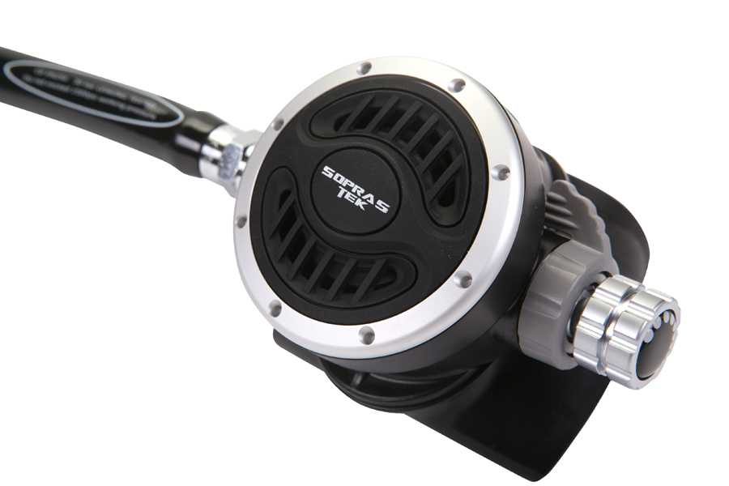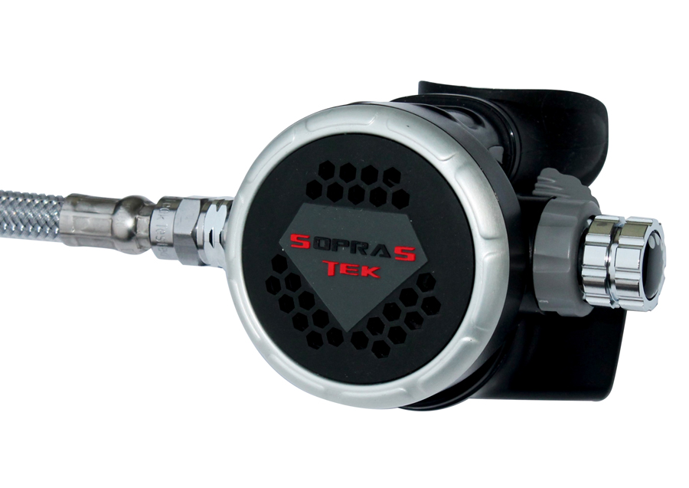

TABLE OF CONTENTS

1. Introduction VENERE (201)-ADJ

2.0 Specifications

2.1 Torque Specifications

3.0 Service Kit List

3.1 Service Tool List

4.0 Service Procedures

4.1 Tools Required for Servicing

4.2 Disassembly

4.3 Cleaning and Inspection

4.4 Preliminary Assembly

4.5 Set-up

5.0 Helpful Hints

5.1 Troubleshooting

5.2 Parts Cleaning Recommendations

5.3 Commonly Used Cleaning Solutions

5.4 Handling Tips

Before You Begin ...........

Read these instructions completely before you begin servicing the regulator or filling whip.

These instructions are intended for people who have been AUTHORIZED by SOPRAS TEK to repair SOPRAS TEK Scuba equipment. If you are not so authorized - STOP.

1.0 INTRODUCTION

1.0.1 The procedures in this manual apply to the SOPRAS TEK VENERE (201)-ADJ 2nd Stage Regulator , Refer to the exploded views as you read the service section of the manual. The Item Numbers referred to in the service section are those seen in the corresponding exploded view in section 2.0 SPECIFICATIONS of this manual.



NEVER tighten the hose fitting to the first stage with more than 40 in. lbs. (4.5 Nm) of torque. The inlet hose fitting will be weakened by over tightening. Failure to heed this warning may result in serious injury or death.

NOTE:

All SOPRAS TEK Scuba Regulators have service kits available which contain the parts which must be changed at every annual service no matter what their condition. The standard annual service kit part numbers are shown in the parts list. All other parts not contained in these kits must be inspected by the technician and changed if necessary. Parts will be handled under warranty, only if they have failed due to problems with material or workmanship.



SOPRAS TEK Scuba Regulators are manufactured using materials suitable for use with oxygen enriched gases (i.e. Nitrox , etc.) providing the oxygen content does not exceed 40%. Equipment intended for enriched air (Nitrox) use, must not be used with regular compressed breathing air or other gases. Regulators intended for enriched air use, can be serviced only by technicians trained by one of the major oxygen enriched air training agencies. Failure to heed this warning may result in serious injury or death.

1.0.2 This manual gives breakdowns of regulator parts, equipment specifications, servicing instructions, troubleshooting recommendations, and guidelines for proper care of SOPRAS TEK regulators. This manual is intended for use only by persons specially trained and authorized to service SOPRAS TEK Scuba equipment.

1.0.3 Anyone attempting to service or repair SOPRAS TEK Scuba regulators must have a thorough understanding of the principles of operation of scuba regulators and valves, as well as the appropriate mechanical ability. The technician must be properly trained in the safe use of compressed air and the various tools and cleaning solutions involved in the procedures outlined in this manual.

1.0.4 The best source for current part numbers for any of the parts listed in this manual is your current parts and price list from SOPRAS TEK.

1.0.5 If you have any questions, or need more information, contact your SOPRAS TEK Sales Representative or SOPRAS TEK Customer Service. You can e-mail you technical questions to SOPRAS TEK’s mail box.

2.0 SPECIFICATIONS





A.

AIR FLOW ............................. 33 cu. ft. (935 liters/min). @ 1 atmosphere

INHALATION RESISTANCE .. 0.9” -2.0” (2.3 - 5.08 cm) w.c. @ 1 atmosphere

EXHALATION RESISTANCE .. 0.6” (1.52 cm) w.c. max. @ 1 atm.

RECOMMENDED LUBRICANT LTI Christo-Lube MCG 111®

B.

TYPE ..........................................Downstream valve, balanced diaphragm, Diver Adjustable Dive / Pre-Dive Venturi Lever and Resistance Control Knob

WEIGHT.......................................0.25 kg ( w/o hose )

MATERIALS ................................Cover ------------- PU  
Case -------------- ABS HI-IMPACT  
Poppet Seat ----- SILICONE   
O-rings ----------- Buna-N  
Diaphragm ------- SILICONE  
Exhaust Valve----- SILICONE  
Mouthpiece ------ SILICONE

* 1. Torque Specifications:

|  |  |  |
| --- | --- | --- |
| Description | Item # | Torque |
| 2nd Stage Nut | 26 | 1-2 ft/lb (2-3 Nm) |
| Hose outlet end |  | 2-3 ft/lb (3-4 Nm) |
| Hose inlet end |  | 2-3 ft/lb (3-4 Nm) |

3.0 SERVICE KIT LIST

|  |  |  |  |
| --- | --- | --- | --- |
| **VENERE (201)-ADJ BALANCE 2ND STAGE REG SERVICE KIT** | | | |
| **NO** | **PART NO** | **DESCRIPTION** | **Q’TY** |
| **11** | **1- 78-19-01** | **O-RING** | **1** |
| **14** | **3-9532** | **O-RING** | **2** |
| **16** | **0193** | **LP SEAT** | **1** |
| **17** | **2- 015-01** | **O-RING** | **2** |
| **21** | **2- 010-01** | **O-RING** | **1** |
| **24** | **2- 019-01** | **O-RING** | **1** |

3.1 SERVICE TOOL LIST

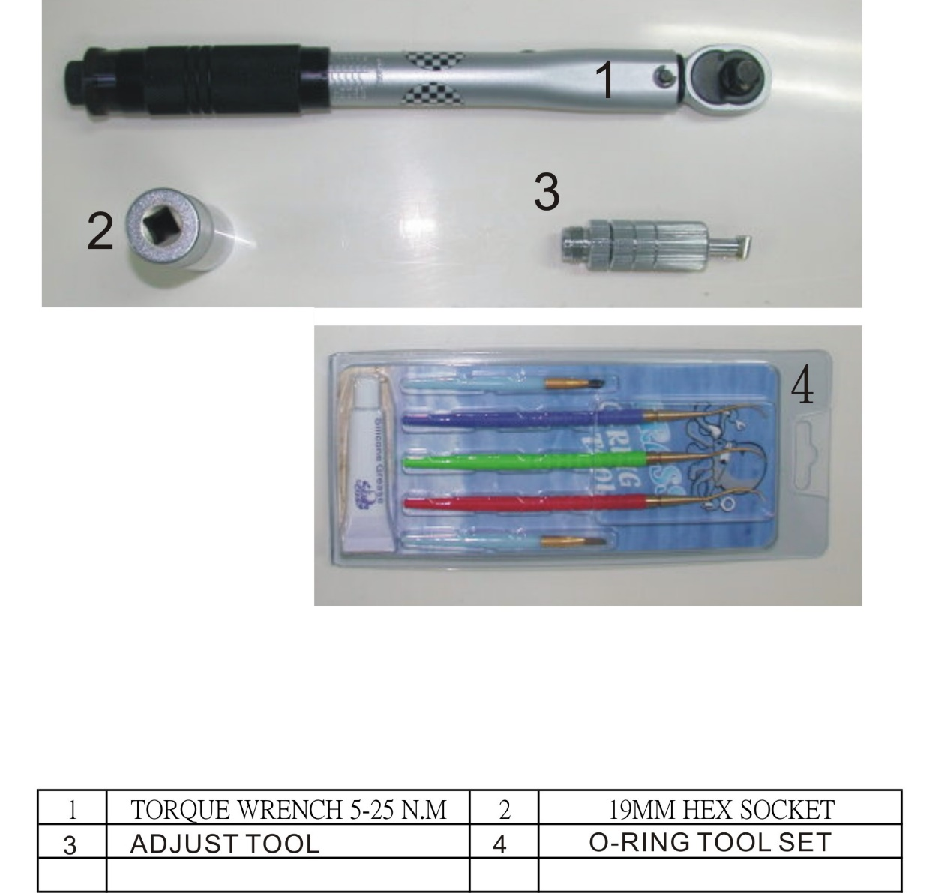

|  |  |  |  |
| --- | --- | --- | --- |
| 1 | TOREQE WRENCH | 3 | ADJUST TOOL |
| 2 | 18MM HEX SOCKET | 4 | O-RING TOOL SEAT |

4.0 SERVICE PROCEDURES

4.0.1 Before you begin disassembly of the regulator, test the first and second stages for output pressures and leakage. Pre-testing in this way will help the technician to pinpoint any specific problems requiring repair.

4.0.2 The work area must be clean and well lighted, with clean compressed air available to blow sand and dirt from parts.

4.0.3 The procedures covered in this manual section apply to the VENERE (201)-ADJ second stage. To access the exploded view of this model see section 2.0 SPECIFICATIONS of this manual.

4.1 TOOLS REQUIRED (or suggested) FOR SERVICING

- 18MM HEX SOCKET

- Adjust tool for second stage

- 2nd Stage Service Kit

- Clean Shop Rags

- Dow-Corning Compound 111 Silicone Grease or LTI Christo-Lube MCG 111

4.2 DISASSEMBLY OF THE SECOND STAGE  


! WARNING !

NEVER tighten the hose fitting to the first stage with more than 40 in. lbs. (4.5 Nm) of torque. The inlet hose fitting can be weakened by over tightening.

To view the complete parts list of the second stage, open the front cover of this manual.

4.2.1   
Use the 6” and 8” adjustable wrenches to loosen the hose nut from the adjust tube (18). Remove the hose assembly from the second stage. Inspect the hose assembly for any cuts or cracks, especially on the hose at the metal ferrules. If found Remove and discard the O-rings from each end of the hose. Clean, rinse, and blow-dry the interior bores of the hoses. Replace the hose assembly if any cuts or cracks are found.

4.2.2   
Examine the condition of the mouthpiece. If the mouthpiece is in good condition, you don’t need to remove it and can be reused. If not remove the mouthpiece (1) by cutting the mouthpiece’s tie (2) with side cutting pliers. Discard the old mouthpiece and tie.

4.2.3  
Put the exhaust cover (5) into the hot water for a moment. Remove the exhaust cover (5) from the housing by pulling it back.

4.2.4   
Before removing the exhaust valve (4) from the housing (3), bend the valve over as far as it will go from the top, bottom, left, and right sides. If it fails to snap back quickly, and does not lie perfectly flat against the housing exhaust grid, the valve should be replaced. If it does snap back satisfactorily, remove it by pulling it out with your fingers. Inspect the sealing edges. If they appear smooth, and the locking tab on the nipple is good, the valve can be reused.

4.2.5   
Unscrew the cover ring (8) from the housing (3).

4.2.6   
Remove the diaphragm washer (7) and the diaphragm (6) from the housing (3). If the cover is difficult to remove you can try several methods to loosen it :   
  
Heat the 2nd stage body surrounding the Ring by running hot water from a tap over it. When the plastic is hot, it will expand and loosen the threads.  
  
Rubber pads are available to use in the hand to loosen tight jar lids. These pads will allow you to get a better grip on the cover ring (8)

4.2.7   
For future reference, look at the lever (20) at this time. Notice how the pivot end of the lever is held into the adjust tube (18) by two plastic flanges on the housing. Note this positioning for re-assembly.

4.2.8   
Hold the diaphragm up to a light source. Gently stretch the diaphragm and look for tear and wear signs or pinholes. If found, replace the diaphragm.

4.2.9   
Loosen and remove the nut (26) from the adjust tube (18)

4.2.10   
Remove the plastic bushing (25) from the adjust tube.

4.2.11   
Remove and discard the O-ring (17) from the adjust tube.

4.2.12   
Turn the Adjust knob (10) fully counterclockwise until it comes to its stop. Do not use an unreasonable force to do this. Stop turning the plug as soon as a resistance is felt.

4.2.13   
Depress the lever (20) fully onto the adjust tube. Grasp the tab of the deflator knob (23). While pulling on the deflator knob (23), push the adjust tube assembly out of the housing (3).

4.2.14   
Remove the deflator knob (23) from the valve tube assembly. Remove and discard the O-ring (24) from the deflator knob (23).

4.2.15   
Turn the ADJUST KNOB (10) clockwise 1/4” turn. The pin (19) will fall out of the adjust tube or can now be easily removed.

4.2.16   
Turn the ADJUST KNOB (10) counterclockwise to remove it from the adjust tube. Remove and discard the O-ring (11).

4.2.17   
Balance cylinder (12), spring (13) and piston (15) are removed at this time. They will often fall out if the adjust tube is tipped on its end.

4.2.18   
Remove and discard the O-ring (17) from the outside of the adjust tube (18).

4.2.19   
Lever (20) should not be removed from the adjust tube unnecessarily. However, it can be removed from the valve body by carefully springing out one of the feet and pivoting it over the adjust tube body. Do not over-bend the lever legs. Straighten the legs if they are bent outward from parallel.

4.2.20   
Remove and discard the LP seat (16) from the piston (15).

4.2.21   
Remove and discard the very small O-rings (14) from the piston. This can be done by pinching a section of the O-ring out of the groove with the fingernails. Then flip the O-ring off the end of the piston stem. DO NOT USE SHARP METAL PICKS! Metal tools will damage the O-ring groove, which will cause a small continuous second stage leak.

4.2.22   
Use a adjust tool to turn the orifice (22) counterclockwise enough turns to fully disengage the threads from the adjust tube (18).

4.2.23   
After the threads are disengaged, remove the orifice (22) from the adjust tube (18) by pulling and turning counterclockwise at the same time.

4.2.24   
Remove and discard the O-ring (21) from the orifice.

4.3 CLEANING AND INSPECTION

4.3.1   
Rinse all plastic and silicone parts in fresh warm soapy water solution. Rinse with clean warm water and then blow the parts dry with compressed air to remove any sand and dust particles.



DO NOT use vinegar or other acid solutions on the plastic parts since this will cause the plastic to become brittle!

4.3.2   
If necessary because of deposits or corrosion, clean all metal parts of the second stage in an ultrasonic cleaner or cleaning solution. See Section 5.3 for recommendations on cleaning solutions.

4.3.3   
Inspect the housing (3) for any cracks or nicks. Look particularly closely at the area where the exhaust valve (4) seals and where the bushing (25) clamps. Replace the housing if any cracks are found.

4.3.4   
Inspect the sealing surface on the orifice (22) (where the seating seat seals ) for any nicks or scratches. Replace the orifice (22) if any serious defects are found at the sealing area, or if the threads appear worn out.

4.3.5   
Blow all dust and debris out of the orifice with clean compressed air.

4.3.6   
Inspect the exhaust valve (4). Look carefully at the base of the barbed nipple where it comes out of the middle of the valve. Look for any tearing at this point. Replace the valve if any tears are found. Replace the valve if nicks or tears are found at the sealing edges of the valve.

4.3.7   
During an Annual Overhaul, all parts included in the Annual Service Kit are replaced no matter what the condition of those parts. Carefully examine all other parts of the second stage for signs of deterioration. Replace those parts too where necessary

4.4 PRELIMINARY ASSEMBLY OF THE SECOND STAGE

4.4.1   
Ensure that all parts are clean. To determine the identity of each O-ring in the Second Stage Service Kit, remove them from the bag and use the O-ring Identification Chart on the back page of this section. Lay each O-ring over its corresponding picture on the page and read the description. Before installing new O-rings into the regulator, lightly lubricate the O-rings with Dow-Corning 111 Silicone Grease or LTI Christo-Lube MCG 111 (EXCEPT O-ring (17) that goes over the adjust tube (18) male threaded end).

4.4.2   
Install the exhaust valve (4) into the case by inserting the nipple into the square hole from the outside of the case. Reach inside the case and pull the nipple firmly with the fingers until you hear or feel it “click” into place. Inspect the exhaust valve to see that it is properly seated. Take care not to get any lubricating grease on the exhaust valve during this procedure.

4.4.3   
Install a new O-ring (17) onto the outside of the adjust tube (18).

4.4.4   
If the lever (20) was removed, carefully re-fit it into the adjust tube (18). To orient the lever properly, hold the valve tube with the external threads to the left. Turn the adjust tube until you can see the hole where the air exits the valve tube. The lever is inserted so that it hangs down and curves leans to the right. Work the lever into the valve tube one foot at a time so the lever legs are spread outwards as little as possible.

4.4.5   
Insert the new seating LP seat (16) into the white piston (15).

4.4.6   
Install the lubricated small O-rings (14) onto the piston tip.

4.4.7   
Install the spring (13) onto the piston and the balance cylinder (12) onto the piston to make the shuttle valve assembly.

4.4.8   
Insert the piston assembly you have just assembled, into the adjust tube (18) at the end with the raised collar (opposite the external threaded end).

4.4.9   
When the piston assembly is inserted into the adjust tube, it is important that the “L” shaped foot on the piston section engages properly with the lever tabs that extend through the holes in the adjust tube.

4.4.10   
Insert the piston assembly. Push the assembly all of the way into the adjust tube. The first thing that might hang up on the tabs of the lever is the LP seat. Wiggle the lever to get this past the tabs. When the “』” shaped feet get to the lever tabs they will lift the lever inwards as you push the assembly in.

4.4.11   
Install a new well lubricated O-ring (11) onto the ADJUST KNOB (10).

4.4.12   
Insert the ADJUST KNOB (10) into the adjust tube over the piston assembly you just installed.

4.4.13   
Turn the ADJUST KNOB (10) clockwise until the O-ring and flange have passed the hole where the pin (19) is installed.

4.4.14   
Install the pin (19) into the adjust tube (18).

4.4.15   
Back the ADJUST KNOB (10) out until it tightens against the pin (19), holding it in place.

4.4.16   
Install the new O-ring (24) onto the deflator knob (23).

4.4.17   
While holding the tabs in place in the adjust tube with two fingers, depress the lever (20) and the slide the deflator knob (23) into place on the adjust tube (18).

4.4.18   
Install the adjust tube assembly into the housing (3). After assembly, make sure that the pivot end of the lever is held into the adjust tube (18) by two plastic flanges on the housing just as they did when you took the housing apart (see step 4.2.7).

4.4.19   
Install the O-ring (17) over the external threaded end of the adjust tube (18).

4.4.20   
Install the bushing (25) (flat side facing the body) over the external threaded end of the adjust tube.

4.4.21   
Install the nut (26) over the external threaded end of the adjust tube. Tighten the nut snuggly 1-2 ft/lb (2-3 Nm) with a wrench.

4.4.22   
Install the new lubricated O-ring (21) onto the orifice (22).

4.4.23   
Use the “ 一/SLOTTED” SCREWDRIVER or ADJUST TOOL to place the orifice into the adjust tube.

4.4.24   
Turn left the shift screw (10) until stop by hand. Deflator knob keep on “Min”. Adjust the orifice (22) with the ADJUST TOOL. It is important that the final adjustment leaves the lever with about 1/8” (3.2 mm) free movement at the end, to allow for the natural wear of the LP seat (16) during the use of the regulator. Adjust the orifice (22) in, while moving the end of the lever up and down with the tip of your finger. When the orifice is too far out you will feel a firm springiness with no free movement. When the seat is too far in you will feel a great deal of looseness at the end of the lever. You want the orifice (22) to be positioned so that you feel the 1/8” (3.2 mm) free play when you move the tip of the lever with your finger.

4.4.25   
Put the exhaust cover (5) into the hot water for a moment. Install the exhaust cover (5) onto the body.

4.4.26   
Install the diaphragm (6) into the housing (3) so that it sits evenly on the ledge. Install the diaphragm washer (7) over the diaphragm. The diaphragm washer (7) is the best tool to align the diaphragm into the body. Screw the cover ring (8) assembly into housing by hand.

4.5 SET- UP OF THE SECOND STAGE

4.5.1   
Keep the adjust tool to inlet nipple.

4.5.2   
Install the hose between a serviced first stage and the second stage, tighten snugly. Use wrenches to tighten the second stage hose connection.

NEVER tighten the hose with more than 40 in. lbs. (4.5 Nm) of torque. The inlet hose fitting can be weakened by over tightening.

Note: Attach the second stage to the overhauled and properly adjusted first stage that it is going to be used with, mounted on an air tank filled to the maximum pressure the regulator is going to be used with. Install an intermediate pressure gauge into one of the low-pressure ports.

4.5.3   
Carefully turn the air on. There should be no air leaking from the second stage with proper intermediate pressure applied to the hose. Adjust the ADJUST TOOL turn left to feel a little leaking and then turn right the orifice until leaking just stop and then turn more 1/8 coil.   
The best test to check for the slightest leaks is to immerse the second stage (with no cover or diaphragm installed) under pressure in water and look for bubbles indicating a leak. Unscrew the cover ring (8) and the diaphragm washer (7) and the diaphragm (6) from the housing (3). Push the lever arm 2 or 3 times. Put the second stage in water and correct the problem if leaks are found. See Troubleshooting section 5.1 for help. Assembly the cover ring assembly and diaphragm again see section 4.4.26.

4.5.4   
Work the lever up and down a few times while the regulator is pressurized. Each time the lever is released, no air hissing should be heard.

4.5.5   
Turn the air off and release all air of regulator set. Loosed and remove the ADJUST TOOL.

5.0 HELPFUL HINTS

5.1 TROUBLESHOOTING

|  |  |
| --- | --- |
| POSSIBLE CAUSE | RECOMMENDED ACTION |
| Inlet filter clogged. | Replace the filter. |
| Air supply to 1st stage insufficient. | Verify the supply air pressure. Make sure the customer had the air valve turned all the way on during the dive. |
| 2nd stage improperly adjusted. | Refer to sections 4.5 and of this manual. |

A. HIGH INHALATION EFFORT AT SURFACE (cracking effort in air):

|  |  |
| --- | --- |
| POSSIBLE CAUSE | RECOMMENDED ACTION |
| 2nd Stage adjusted improperly | Refer to sections 4.5 of this manual. |
| 2nd stage spring force on high end of range | The spring (13) can be conditioned to a lower thrust. This is done by squeezing it down (with a vise or fingers) to near solid height (8.9mm) where the space between the coils is the same as the thickness of the spring wire. Do not squeeze the spring coils completely closed as this will result in too low a cracking effort. Note: This will lower the cracking effort in air, but will have little or no effect on the underwater performance. It is usually not necessary and should only be done if the customer understands that a low cracking effort makes a regulator more prone to hissing and will probably need more frequent adjusting. If the spring is over squeezed during this conditioning, so that the coils touch each other, the 2nd stage may hiss when the adjust knob or shift screw is turned all of the way out. Turning the knob in (clockwise) slightly will stop the hissing if this is the case. If the hissing does not stop, the orifice (22) needs adjusting, or the LP seat (16) needs replacing. |

B. CREEPING INTERMEDIATE PRESSURE:

|  |  |
| --- | --- |
| POSSIBLE CAUSE | RECOMMENDED ACTION |
| Damaged or worn 1st stage | Replace 1st stage |

C. HISSING FROM SECOND STAGE (but intermediate pressure is OK):

|  |  |
| --- | --- |
| POSSIBLE CAUSE | RECOMMENDED ACTION |
| Damaged or worn 2nd stage LP seat (16) | Replace LP seat |
| Nicked orifice (22) sealing surfaces | Replace orifice |
| 2nd stage demand lever (20) bent too high | Replace lever |
| Worn O-ring (21) on orifice (22) | Replace O-ring |
| Worn O-ring groove on orifice (22) | Replace orifice |
| Orifice (22) out of adjustment | Adjust orifice |

D. WET BREATHING:

|  |  |
| --- | --- |
| POSSIBLE CAUSE | RECOMMENDED ACTION |
| Diaphragm improperly installed or hole in diaphragm | Check position of diaphragm visually. Replace if holes found by holding up to a light. |
| Damaged or loose fitting exhaust valve | Replace exhaust valve (4) |
| Crack in housing (3) | Replace housing |
| Worn O-rings (17,24,11) | Replace O-rings (17,24,11) |
| Scratched or worn bushing (25) sealing surfaces | Replace bushing (25) |
| Scratched or worn housing (3)  sealing surfaces | Replace housing |
| Improper clearing techniques by diver | Instruct diver on clearing techniques |
| Extremely slow breathing allowing water to build up in housing rather than being blown out | Explain this result of slow breathing to diver. |

E. HIGH FREQUENCY HUMMING OR BUZZING DURING INHALATION:

|  |  |
| --- | --- |
| POSSIBLE CAUSE | RECOMMENDED ACTION |
| Harmonic resonance between the springs and other 1st stage components. | Change the 1st stage |

F. LOW FREQUENCY FLUTTERING DURING INHALATION (Above the surface only):

|  |  |
| --- | --- |
| POSSIBLE CAUSE | RECOMMENDED ACTION |
| Harmonic resonance between the springs and other 2nd stage components. | Remove, rotate and re-install diaphragm or switch diaphragm with another. |
| Replace seating LP seat (18) |
| Remove, rotate and re-install spring (13) |
| Explain to the customer that this is not harmful to the regulator, and does not happen underwater. |

5.2 PARTS CLEANING RECOMMENDATIONS

5.2.1   
Regulators that see heavy use, particularly those used in salt water, often require extra effort to remove dirt and corrosion from the parts of the regulator. Some suggested cleaning solutions are listed at the end of this section, and there are probably many others being used successfully. The following are a few general suggestions we can make.

5.2.2   
Don’t expect your cleaning solution to do all the work in a matter of seconds. If the solution cleans extremely rapidly, it is probably too strong and is etching the finish on the parts. Use a wooden or plastic stick or bristle brush to get rid of the thickest deposits. Take special care not to damage orifice sealing areas.

5.2.3   
Soft parts absorb ultrasonic energy. Remove all O-rings and seals from metal parts before cleaning them. If possible, do not clean plastic parts with the metal parts, or at least understand that every plastic part you put into the ultrasonic cleaner is slowing down the ultrasonic cleaning process for the rest of the parts.

5.3 COMMONLY USED CLEANING SOLUTIONS

|  |  |
| --- | --- |
| SOLUTION | COMMENTS |
| Hot Soapy water | Preferable. Good for plastic, silicone and plated metal parts. |
| Vinegar and water  (equal part solution)  (weaker solution in Ultrasonic Cleaner) | Ingredients easily available.  Approx. 15 min. cleaning time.  May damage chrome finish.  Never use on plastic parts.  Vinegar dissolves the plastics in most polymers making them brittle and more prone to breakage. |
| Simple Green R and Water | Simple Green is a readily available degreaser. Read the product label for mixing ratios with water. |
| Cleaning solutions recommended by ultrasonic cleaner manufacturers | The preferred choice. Check with the manufacturer for strengths and recommended uses for their cleaners. Choose soap solutions over acidic ones. |

5.4 HANDLING TIPS

How your customers treat their regulators will directly influence the unit’s function and durability.

Following are a few tips that you can pass on to your customers to help assure the durability of their SOPRAS TEK Scuba Regulator.

A. PRE-DIVE CHECKS:

5.4.1   
Check the hoses and hose connections for cuts, abrasions or other signs of damage before mounting the regulator on the tank valve. Slide the hose protectors back to inspect the areas of the hose normally covered. Be sure all hose connections are tight.

5.4.2   
Just before mounting the regulator on the valve, always turn the valve on briefly to blow any trapped water out of the valve. There is often salty water trapped in the outlet side of the valve. This entrapped salt water being blown through the interior of the regulator is the number one source of internal corrosion and problems with Scuba regulators.

5.4.3   
Before turning on the tank air valve, check to make sure that the yoke nut or DIN connection is tight and the regulator body is aligned properly, with no kinks in the hoses.

5.4.4   
Turn the tank valve on slowly and listen for leaks. If any leaks are found, replace or repair parts as recommended.

5.4.5   
Never lift the tank/BCD assembly by the regulator or hoses.

5.4.6   
Surface-test the regulator by breathing lightly through the mouthpiece. Depressing the purge button above the water's surface is not an effective or thorough method for testing the function of the regulator.

B.POST-DIVE CARE:

5.4.7   
After the dive, blow all water out of the dust cap with clean dry air or dab the water out with an absorbent cloth and place the cap securely on the regulator inlet. On multiple tank dives, use great care to keep salt water out of the regulator inlet when tanks are changed. Neglecting these simple procedures is another great cause of corrosion and wear in Scuba regulators.

5.4.8   
With the dust cap securely in place, rinse the first and second stages in clean fresh water. DO NOT depress the purge button before or during rinsing since this may introduce water into the second stage and the low-pressure hose. Shake or blow all excess water from the second stage and allow the entire regulator to air-dry before storing.

5.4.9   
Store regulator in a clean bag or storage box, away from sunlight, excessive heat and humidity.