

SY 4500 Primary Torch
www.soprastek.com

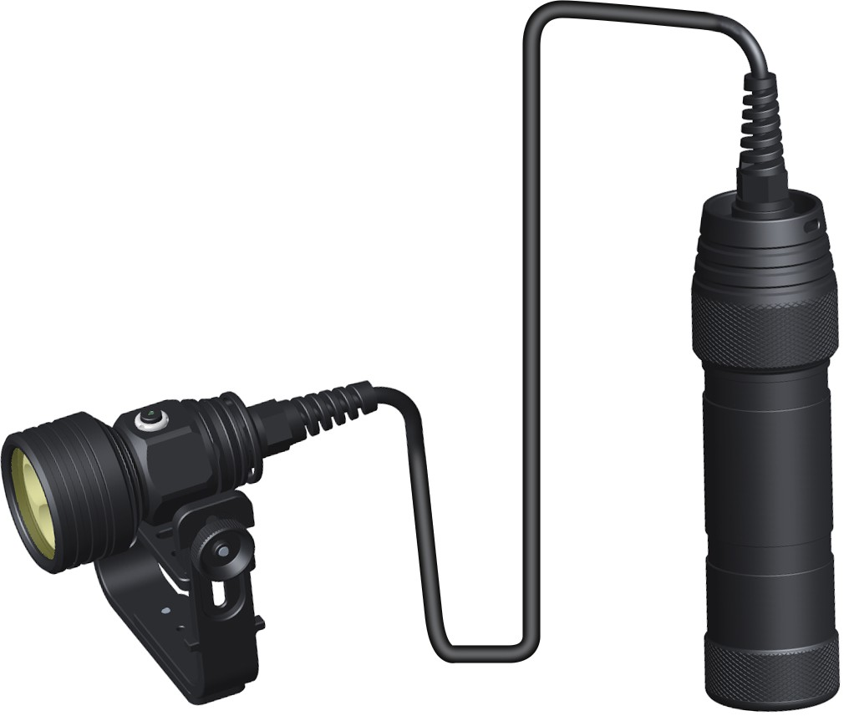

Max 4550 lumens

Product Specification

Utilize 5 ultra bright LED, max 4550 lumens output

Powered by 8*18650 rechargeable lithium battery, the max runtime reaches to 24hrs

Over-heat protection design to ensure working stable and safe use. Reverse polarity protection to prevent from wrong installing of battery Mechanical button switch for easy operating on/off and changing modes underwater

Three o-rings offer extremely waterproof capacity of maximum 150 meters underwater

The light body is made of Aircraft-grade aluminum AI T6061-T6 for durable use

Surface processed by premium military grade hard -anod ized with high performance of abrasion and corrosion resistance

The toughened lens with thickness 4mm to ensure excellent ability of resistance water pressure

Standard accessories: spare O-rings, lanyard, user manual and kraft box

Technical Parameters

ANSI | High | Medium | Low | Strobe
Lumen Output(Focus) | 4550 lumens | 1750 lumens | 420lumens | /
Run Time(1*18650) | 4h 30mins | 7h 50mins | 24hrs | /
Beam Angle | 6.8°
Battery | 8*18650 Rechargeable Li battery
WaterProof | IPX-8(Underwater 150m)
Dimension | Head Dia 60mm/Canister Dia 60mm  /Canister Length 209mm
Net Weight | 2.1kg(include the battery pack)

Operation

DIV10PRO use mechanicaL button switch, which can offer different brightness according to the need of users.

- Brightness
With the light turned off, press the switch to turn the light on. With the light turn on, press the switch down repeatedly to cycle through the following output: High-Middle-Low-Off.
- Lock function
With the light turned off, press and hold the switch for more than 5 seconds to lock the light; Double click the button to unlock the torch.

Maintenance

Please immerse the diving flashlight in the fresh water for few minutes after diving every time and dry the flashlight after immersing

Please put lubricating oil on the switch parts after diving

Please don't drop or place your diving flashlight in sands, in case the sands go into the switch or screw threads

Please keep inspecting the O-rings regularly, and change a new one once they are damaged in time

Please take the battery out of the light when you want the light to be stored in case of damage caused by battery

All the connection parts are all sealed by glue, please do not try to open them

Warranty Policy

15 days free replacement

We wilI replace a new product within 15 days of purchase for any manufacturing defects if problems come into being with normal use. We will replace it with the same model,If the model has been discontinued,customers wilI receive a product with similar or improved model.

Free repairs
We will offer free repair for lights from the date of purchase if the issues caused by normal use. Different warranty period for different products below:

Dive light | One year
Battery,charger | Six months

Lifetime repairs

For lights past the free repair warranty period , we provide lifetime repairs but will onIy charge for parts, the total repair fee is dictated by the cost of the replaced materials onIy.

The free warranty does not cover any damages or failure caused by the followings:
- Normal wear
- Rough operation
- Battery leakage

